**Case Study Proposal**

**Dayana Fernandez**

**Towson University**

**AIT 715**

**Dr. Dehlinger**

**January 17, 2018**

Proposal Date: 1/17/18

**AIT CASE STUDY COVER SHEET**

Course

X AIT 715

Student Name: Dayana Fernandez

Semester: Spring 2018

Case Study Title: Fernandez Translation Services website

Advisor Name: Dr. Josh Dehlinger

**Abstract:** The purpose of this case study project is to design and develop a website to promote translation services. I would like a website to provide information and advertise my services both in written and oral translations from English to Spanish and Spanish to English. Users will be able to request services through the site and get an estimated cost for their requested translation. Furthermore they will be notified of the approximate time of completion and asked to confirm if they accept or decline this timeline. Based on their answer, they will be notified if their translation request has been accepted or denied. The major objective for this project is to develop a website that will work on all web browsers. HTML, JavaScript and JQuery will be used for the development of this website. This will have an impact because although I have done a few translations, I don’t currently have a website that allows me to advertise my services. One of my goals is to get professionally certified so that I can expand my abilities and be able to reach out to a broader audience, so this website will also aid me in making this happen.

Past Courses: Please list all courses completed and currently taking. Remember that you must complete all prerequisites in order to register for a case study.

|  |  |  |  |
| --- | --- | --- | --- |
| ***Number*** | ***Name*** | ***Semester*** | ***Grade*** |
| AIT 500 | Fundamentals of Computer Programming and Data Structures | Spring 2016 | S |
| AIT 600 | Information Technology Infrastructure | Spring 2016 | A |
| AIT 610 | Systems Development Process | Spring 2016 | B+ |
| AIT 612 | Information Systems Vulnerability and Risk Analysis | Fall 2016 | A |
| AIT 624 | Software Engineering Fundamentals | Fall 2016 | A- |
| AIT 628 | Information Technology and Business Strategy | Fall 2016 | A |
| AIT 613 | Introduction to Software Security | Spring 2017 | A |
| AIT 616 | Fundamentals of Web Technologies and Development | Spring 2017 | B |
| AIT 630 | Information Technology Project Management | Spring 2017 | A |
| AIT 614 | Network Security | Summer 2017 | A |
| AIT 632 | Database Management Systems | Summer 2017 | A- |
| AIT 732 | Advanced Database Management Systems | Fall 2017 | A |
| AIT 618 | Client/Server-Side Programming on the Web | Fall 2017 | B+ |
| AIT 710 | Case Study in Information Security | Fall 2017 | A- |
| AIT 620 | Business Data Communications | Spring 2018 |  |
| AIT 670 | Cloud Computing | Spring 2018 |  |
| AIT 715 | Case Study in Internet Applications | Spring 2018 |  |

**FOR OFFICE USE ONLY**

Proposal Approved:

Report Received:

Proposal Title: *Fernandez Translation Services website*

# Problem Description

# The project will be a website that will advertise my translation services. I will offer written translation services both from English into Spanish and Spanish into English. The scope of this project will be the requirements, design and development of a website that will work on multiple web browsers. I would also like to make the site mobile-enabled but based on timeframe, I think that will be outside the scope of this case study, so it will be something I will focus on in the future. Another future plan is to provide users the option of viewing the site in Spanish in order to accommodate users who don’t speak English.

The objective and main outcome of this project is the delivery of a fully functional and live website that will allow customers to elicit my services and allow me to interact with them as well. The first deliverable is this proposal in order to be granted permission to work on the project. The second deliverable will be a prototype of the initial look of the site in order to make sure that it meets all required web standards. The subsequent deliverables will be each individual page that will be part of the overall site. The final deliverable will be the live and functional site.

# Justification of the Problem

This case study is suitable because it aligns with all the concepts taught in Fundamentals of Web Technologies and Development. I will have to use the knowledge gained in the course in order to design the site and make sure that I am following the required web standards. I will also have to tap into the knowledge gained in Client/Server-Side Programming on the Web in order to keep back-end requirements in mind as I am designing. The Amazon Web Services knowledge from this course will also be important, as that is the web platform I will be using to take the site live.

All of the above learning elements from this project are suitable because they will allow me to make a website that will be used to provide services and use the finished product as something tangible to show my capabilities during potential job interviews. I think it will be suitable as a capstone project because the final product will have several pages, which will be dynamic and interactive, which will add to the complexity. All of the elements and nuances will be carefully thought-out and planned in order to provide the most complete site possible.

# Preliminary Design Plan

1. **Use Cases**
2. The system shall allow users to create an account.
3. The system shall allow users to request services
4. The system shall allow users to see an estimated cost of service
5. The system shall allow users to see a timeline of service completion
6. The system shall show users whether their service request has been accepted or denied.
7. The system shall allow users to contact me for any questions they may have.
8. The system shall allow users to post reviews on services received.
9. The system shall allow translation material files to be exchanged between the users and I once the job has been accepted.
10. The system shall allow translation material files to be exchanged between the users and I once the job has been completed.
11. The system shall allow storage of a searchable repository of original texts.
12. The system shall allow storage of a searchable repository of translated material.
13. **Framework**

The framework for the website will be HTML 5, Javascript and JQuery. These will be used in order to make the website dynamic and interactive, in order to provide visitors with the best and most effortless experience possible. HTML 5 will serve as the main framework, while Javascript and JQuery will provide the enhancements and dynamism. This will make it easy and seamless for users to navigate, regardless of their level of experience using the world wide web.

1. **Architectural Plan & Justification**

When a user visits the site they can create an account in order to request services. This account page will allow them to see information on the preliminary completion timeframe of their requested translation in order for them to decide whether the projected timeframe works for them. If they accept the timeframe, then I will provide a projected price range. If the timeframe doesn’t work for them, then they will get a message that says that unfortunately I can’t provide the service. All of this information can be seen on their personal account page. The home page will contain information about the purpose of the site. The about page will contain information about who I am. The services page will detail the types of services that I can provide, as will as general pricing and timelines. The contact page will provide my information in order for users to contact me for any questions they may have. The reviews page will give users a place to read and post reviews on the service they received.

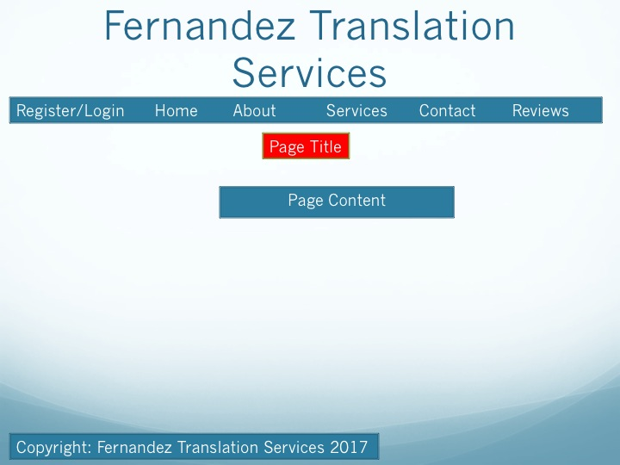

# Preliminary Schedule

|  |  |  |
| --- | --- | --- |
| Activities | Estimated Time (in hours) | Dates |
| Reading material consulted | 5 | January 29, 2018 |
| Reading continued | 5 | January 30, 2018 |
| Brainstorming initial feel and look of website | 10 | January 31, 2018 |
| Wireframe of first page prepared | 5 | February 5, 2018 |
| Advisor meeting | 1 | February 6, 2018 |
| First page coded and constructed | 10 | February 12, 2018 |
| Wireframe of second page prepared | 5 | February 26, 2018 |
| Advisor meeting | 1 | February 27, 2018 |
| Second page coded and constructed | 15 | March 5, 2018 |
| Wireframe of third page prepared | 5 | March 10, 2018 |
| Advisor meeting | 1 | March 12, 2018 |
| Third page coded and constructed | 15 | March 19, 2018 |
| Wireframe of fourth page prepared | 5 | March 26, 2018 |
| Advisor meeting | 1 | March 27, 2018 |
| Fourth page coded and constructed | 14 | April 2, 2018 |
| Wireframe of fifth page prepared | 5 | April 9, 2018 |
| Advisor meeting | 1 | April 10, 2018 |
| Fifth page coded and constructed | 10 | April 16, 2018 |
| Wireframe of last page prepared | 5 | April 17, 2018 |
| Last page coded and constructed | 12 | April 18, 2018 |
| Advisor meeting | 1 | April 24, 2018 |
| Finishing touches | 3 | April 26, 2018 |
| Final report/deliverable wrap-up | 5 | May 1, 2018 |

# Bibliography/Reading List

Benedetti, R. & Cranley, R. (2011). Head First jQuery. O’Reiley Media, Inc. Sebastopol, California.

Duckett, J. (2011). HTML & CSS: Design and Build Websites. John Wiley & Sons, Inc. Indianapolis, Indiana.

Duckett, J. (2014). Javascript & JQuery: Interactive Front-end Web Development. John Wiley & Sons, Inc. Indianapolis, Indiana.

Freeman, E. & Robson, E. (2011). Head First HTML5 Programming: Building Web Apps with JavaScript. O’Reiley Media, Inc. Sebastopol, California.

Karlins, D. & Sahlin, D. (2012). Building Websites All-in-one for Dummies. John Wiley & Sons, Inc. Hoboken, New Jersey. Third Edition.

McFedries, P. (2008). The Complete Idiot’s Guide to Creating a Website. Alpha: Penguin Group, Inc. New York, New York.

Mihajlov, M. (2015). HTML Quickstart Guide: The Simplified Beginner’s Guide to HTML. ClydeBank Media LLC. Albany, New York.

Minnick, C. & Holland, E. (2015). Coding with Javascript for Dummies. John Wiley & Sons, Inc. Hoboken, New Jersey.

Robson, E. & Freeman, E. (2012). Head First HTML and CSS: A Learner's Guide to Creating Standards-Based Web Pages. O’Reiley Media, Inc. Sebastopol, California. Second Edition.

Robson, E. & Freeman, E. (2014). Head First Javascript Programming. O’Reiley Media, Inc. Sebastopol, California.

Sabin-Wilson, L. (2017). WordPress All-in-One for Dummies. John Wiley & Sons, Inc. Hoboken, New Jersey. Third Edition.

Siarto, J. (2010). Head First WordPress. O’Reiley Media, Inc. Sebastopol, California.

Sommerville, I. (2011). Software Engineering. Addison-Wesley. Boston, Massachusetts. Ninth Edition.

Watrall, E. & Siarto, J. (2009). Head First Web Design: A Learner's Companion to Accessible, Usable, Engaging Websites. O’Reiley Media, Inc. Sebastopol, California.

I, _____Dayana Fernandez_____ propose to complete this project during the __*spring*__ semester of __*2018*__ and understand that this project and its derived materials (e.g., source code, written reports, presentation slides) are to reflect my own work, unless explicitly and appropriately referenced. Furthermore, I understand that plagiarism or other unattributed use of material not written by me is completely unacceptable, and **will be considered sufficient cause for a failing grade on the project.** For additional information on academic integrity policy at Towson University, I will visit [www.towson.edu/provost/resources/studentacademic.asp](http://www.towson.edu/provost/resources/studentacademic.asp) .

Student’s Signature: ___Dayana Fernandez___________________

Instructor’s Signature: _____________________

Graduate Program Director’s Signature: ______________________________